**STRATEGIC INVESTMENT AND FINANCING DECISIONS**

**UNIT-I**

INVESTMENT DECISION UNDER CONDITIONS OF RISK AND UNCERTAINITY:

**Definition:** The **Investment Decision** relates to the decision made by the investors or the toplevel management with respect to the amount of funds to be deployed in the investment opportunities.

Simply, selecting the type of assets in which the funds will be invested by the firm is termed as the investment decision. These assets fall into two categories:

1. **Long Term Assets**
2. **Short-Term Assets**

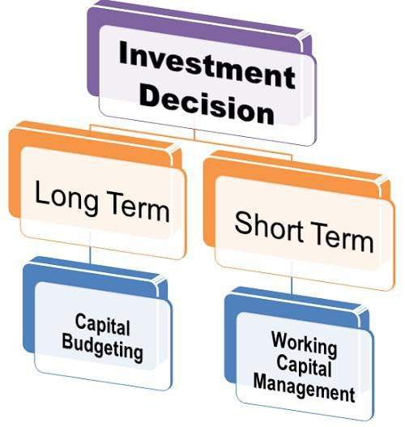

The decision of investing funds in the long term assets is known as **Capital Budgeting.** Thus, Capital Budgeting is the process of selecting the asset or an investment proposal that will yield returns over a long period.

The first step involved in Capital Budgeting is to select the asset, whether existing or new on the basis of benefits that will be derived from it in the future.

The next step is to analyze the proposal’s uncertainty and risk involved in it. Since the benefits are to be accrued in the future, the uncertainty is high with respect to its returns.

Finally, the minimum rate of return is to be set against which the performance of the long-term project can be evaluated.

The investment made in the current assets or short term assets is termed as **Working Capital** **Management**. The working capital management deals with the management of current assetsthat are highly liquid in nature.

The investment decision in short-term assets is crucial for an organization as a short term survival is necessary for the long-term success. Through working capital management, a firm tries to maintain a trade-off between the profitability and the liquidity.

In case a firm has an inadequate working capital i.e. less funds invested in the short term assets, then the firm may not be able to pay off its current liabilities and may result in bankruptcy. Or in case the firm has more current assets than required, it can have an adverse effect on the profitability of the firm

Thus, a firm must have an optimum working capital that is necessary for the smooth functioning of its day to day operations.

INVESTMENT DECISIONS UNDER RISK AND UNCERTAINITY:

In the present Scenario, estimation of future cash flows is not as easy task. Every decision involves a risk factor and it is not possible to estimate accurate percentage of risk, hence it may lead to wrong decision when estimated cash flows are not equal to actual cash flows.

Capital budgeting decisions are significant due to many reasons and if the decision is wrong then it may cause lose of scarce resources. Therefore it is necessary to adjust the future cash flows with the risk. So that it can minimize the difference between estimated and actual cash flows.

Risk and uncertainty are used interchangeably but they have some difference Risk can be estimated up to certain limit whereas uncertainty is of unpredictable nature which cannot be estimated. Risk is defined as the changes that are possible to occur in the future cash flows of specific investment proposal.

In order to manage risk many techniques are developed. They are,

|  |  |  |  |
| --- | --- | --- | --- |
| Conventional Techniques | | Statistical Techniques | |
|  |  |  |  |
| 1. | Risk adjusted discount rate | 1. | Probability distribution approach |
| 2. | Certainty equivalents | 2. | Decision tree approach |
| 3. | Sensitivity analysis |  |  |
|  |  |  |  |

CONCEPTS OF RISK AND UNCERTAINITY:

Decision-making helps the decision maker in choosing the best course of action from the available courses of action. The decision-making models are classified on the basis of information about the state of nature and the decision environment are classified into three types as follows,

1. Decision-making under certainty.
2. Decision-making under risk.
3. Decision –making under uncertainty.
4. Decision-making under certainity

This is one fo the easiest from of decision-making. The outcome from the selection of a particular course of action is given with certainty. Each state of nature has one course of action which has probability. Complete and correct information and knowledge of the consequent of each choice is being provided. As such the decision holds the perfect knowledge about the future outcome, he/she chooses that course of action which pays him the maximum/optimum payoff.

Few techniques are as follows,

* 1. Input –output analysis
  2. Break even analysis
  3. Goal programming
  4. Transporation and assignments methods
  5. Inventory models under certainty

II.Decision-making under Risk

Decision making under risk assumes the long-run relative frequency of the states of nature occurrence to be given and besides this it also enumerates several states of nature. The state of natures information is probabilistic in nature i.e, the decision maker cannot predict which outcome will occur as a result of selecting a particular course of action. As each course of action results in more than one outcome, it is not easy to calculated the exact monetary payoffs or outcomes for the various combination of courses of action and states of nature.

1. Decision-making Under Uncertainty

The decision maker has to determine the expected payoff for the courses of action or strategies as the probabilities associated with the occurrence of states of nature are not given. The decision maker has number of criteria available and has to select one among them. The selection depends upon the attitude of the decision maker and the polich of an organisation.

1.Criterion of Optimism or Maximin: Maximin initially identifies the worst possible outcome for each course of action i.e., maximin loss or minimum outcome that would occur under each decision alternative and then choosing the best out of the worst outcome is order to select the optimal course of action or strategy.

1. Criterion of Optimism or Maximax : Maximax is totally reverse of maximin operations research criterion of pessimism. Maximax identifies the best possible outcome associated with each course of action and then choose the maximum of the maximum value in order to select the optimal course of action or strategy.
2. Minimax Regret Criterion: Minimax regret criterion is useful in identifying the regret which is associated with each states of nature if a specific course of action is undertaken.
3. Hurwitz Criterion or Criterion of Realism: A rational decision maker should not be either completely optimistic or pessimistic. Hurwitz introduced the idea of coefficient of optimism.

0≤∝≤1

1. If a is close to 1, the decision-maker is optimistic about the future
2. If a is close to zero, the decision-maker is pessimistic about the future. According to Hurwitz, select the strategy that maximizes.

H=a (Maximum payoff in column)+(1-a)(Minimum payoff in column).

5. Criterion of Rationality or Baye’s or Laplace Criterion: Laplace criterion is based on the principle of equal likelihood or insufficient reason. According to this principle, as probabilities of future states of nature is unknown, there is no reason to consider any one outcome more likely than the other i.e, all outcomes must be considered equally likely. With outcomes, each outcomes will thus have a probability of 1/n .with the help of these probabilities such a course of action must be chosen which has the highest expected loss.

Sources and perspectives of Risks:

Risk is common in every business, it is the probability of happening something wrong in future. A project involves risk which emerge from different sources. Some of the important sources are explained below,

Sources of Risk

1. Project Specific Risk
2. Competitive Risk
3. Industry Specific –Risk
4. Market Risk
5. International Risk

Perspective of Risk

1. Stand-alone risk
2. Firm Risk
3. Market Risk.

UNIT-II

INVESTMENTS AND DISINVESTMENTSINV

Money spent on acquiring a commodity which has the potential of making future income or wealth is known as investment. In simple terms, investment is engaging money today to maximise it in the future. An investor can be anyone, an individual, a business entity or even the government.



ESTMENTS AND DISINVESTMENTS

INVESTMENTS AND DISINVESTMENTS

1. **Investor**: An investor can be any individual, firm or organization who has the potential of engaging one’s capital for a long-term period (usually more than a year) to earn profit or wealth in future.
2. **Speculator**: Speculators usually invest the borrowed sum in the high- risk bearing opportunities for a short-term period (not exceeding six months) to earn high returns. They rely on calculations based on market trend, psychology and technical analysis.
3. **Trader**: Traders are the ones who deal in the derivatives market or the stock market, buying and selling their holdings within a day or a week or a month. They aim to earn a profit in the form of margins derived from price fluctuation.
4. **Gambler**: Gambler is the person who put in money or valuables without any basis or calculations in a game of luck or chance. He/she invests in betting, playing cards, tosses, etc., knowing that the outcome is uncertain.

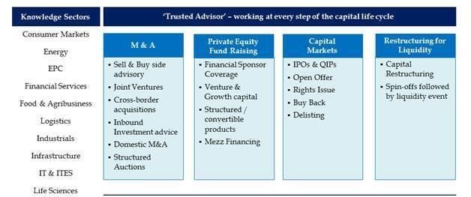

Ii

**INVESTMENTS**

* **Time**: The period for which the investment is made must be at least one year. More extended the term period of investment is, higher will be the return yield. Investments like government bonds depend on this factor.
* **Risk**: Every investment bears some risk. Higher the potential of the investor to take a chance, better will be the return he gets. Stock market investments are majorly influenced by this factor.



**CAPITAL BUDGETING PROCESS:**

* 1. **Proposal generation**. Proposals for new investment projects are made at all levels within a business organization and are reviewed by finance personnel.
  2. **Review and analys**is. Financial managers perform formal review and analysis to assess the merits of investment proposals
  3. **Decision making**. Firms typically delegate capital expenditure decision making on the basis of dollar limits.
  4. **Implementation.** Following approval, expenditures are made and projects implemented. Expenditures for a large project often occur in phases.
  5. **Follow-up**. Results are monitored and actual costs and benefits are compared with those that were expected. Action may be required if actual outcomes differ from projected ones.

1. 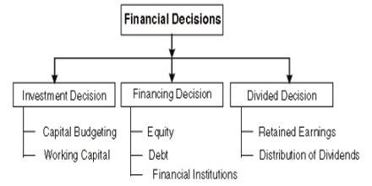 **Step1:** Involved in Capital Budgeting is to select the asset, whether existing or new on the basis of benefits that will be derived from it in the future.
2. **Step2** : The next step is to analyze the proposal’s uncertainty

and risk involved in it. Since the benefits are to be accrued in the future, the uncertainty is high with respect to its returns.

1. **Step3** : the minimum rate of return is to be set against which the **performance of the long-term project can be evaluated**

**TYPES OF INVESTMENT**

Money spent on acquiring a commodity which has the potential of making future income or wealth is known as investment. In simple terms, investment is engaging money today to maximize it in the future. An investor can be anyone, an individual, a business entity or even the government.

Risk can be measured and quantified, through theoretical models. Conversely, it is not possible to measure uncertainty in quantitative terms, as the future events are unpredictable.

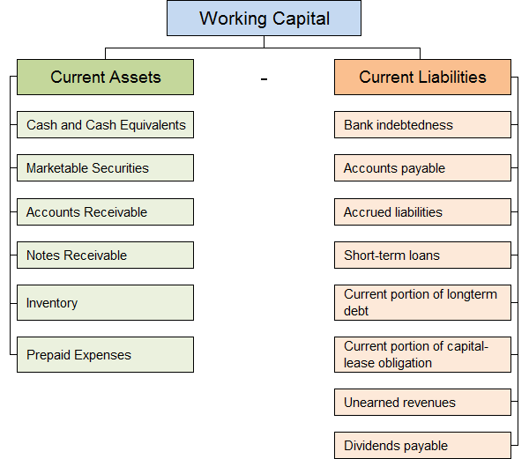

.

* + To acquire additional capital assets for expansion, enabling the business to, for example, increase unit production, create new products, or add value;
  + To take advantage of new technology or advancements in equipment or machinery to increase efficiency and reduce costs
  + To replace existing assets that have reached end-of-life (a high-mileage delivery vehicle or an aging laptop computer, for example)

payback method:

1. The payback method is widely used by large firms to evaluate small projects and by small firms to evaluate most projects.
2. Its popularity results from its computational simplicity and intuitive appeal.
3. By measuring how quickly the firm recovers its initial investment, the payback period also gives implicit consideration to the timing of cash flows and therefore to the time value of money.
4. Because it can be viewed as a measure of risk exposure, many firms use the payback period as a decision criterion or as a supplement to other decision techniques.
5. **Pay-Back Period Method-** It is defined as the number of years required to recover original cost invested in a project. It has two conditions
6. ⦿ When cash inflow is constant every year PBP= Cash outflow/cash inflow (p.a.)
7. ⦿ When cash inflow are not constant every year
8. PBP = Completed years + required inflow * 12

inflow of next year

**Average Rate of Return Method:**

ARR means the average annual earning on the project. Under this method, profit after tax and depreciation is considered. The average rate of return can be calculated in the following two ways.

ARR on average investment = Average profit after tax

Average investment

ARR on initial investment = Average profit after tax

Initial investment

**Discounted Pay-Back Period Method** –

In discounted pay- back period method, the cash inflows are discounted by applying the present value factors for different time periods. For this, discounted cash inflows are calculated by multiplying the P.V. factors into cashinflows.

Discounted = completed years + Required inflow

Inflow of next year

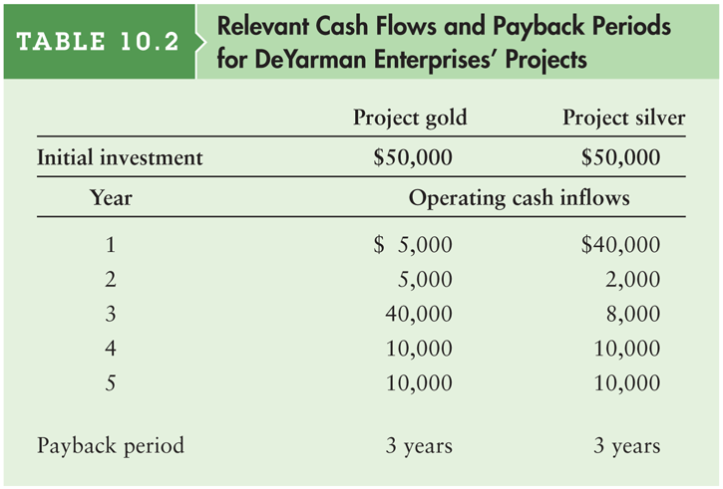

**Net present value (NPV)** is a sophisticated capital budgeting

technique; found by subtracting a project’s initial investment from the present value of its cash inflows discounted at a rate equal to the firm’s cost of capital.

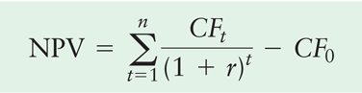NPV = Present value of cash inflows – Initial investment

* **Evaluation of Net Present Value Method:-**
* Project with the higher NPV should be selected.

Accept NPV>0

if Reject NPV<0

May or may not accept NPV=0

## Internal Rate of Return Method:-

IRR is the rate of return that a project earns. The rate of discount calculated by trial and error , where the present value of future cash flows is equal to the present value of outflows, is known as the Internal Rate of Return.

IRR = LDR + NPV @LDR * (HDR –LDR) NPV@LDR –NPV @ HDR

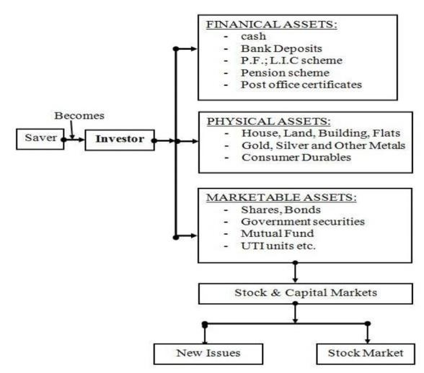

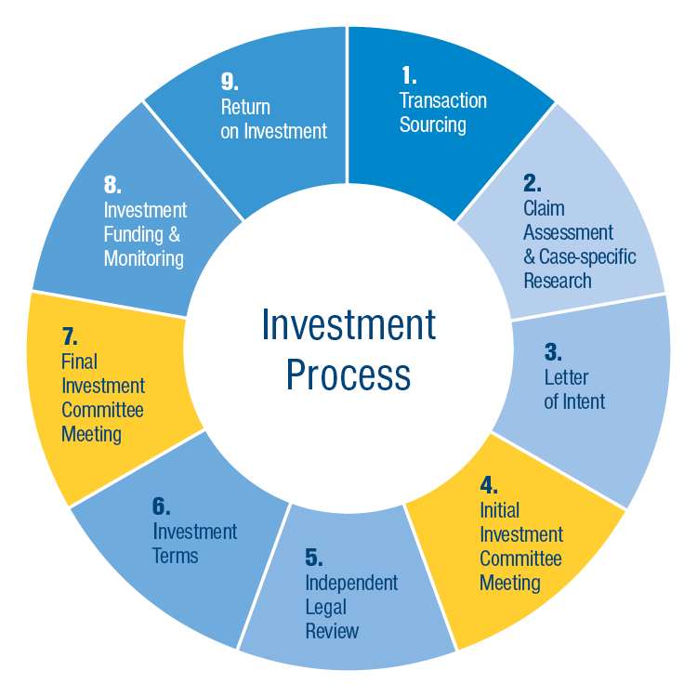

## Stocks and equities

Stocks and equities are one of the most common types of growth- oriented investment avenues that can help you grow the value of your original investment over a medium to long time interval.

## Debt Mutual Funds

Debt mutual funds are a mix of fixed income securities, such as Treasury Bills, Government Securities, Corporate bonds, liquid or money-market funds, short-term income funds, gilt funds, and other debt securities of different time horizons. These have a fixed maturity date and pay a fixed rate of interest.

## Fixed Deposits

Fixed Deposits are financial instruments where you can invest a lumpsum amount, to earn guaranteed returns. Your investment can be locked in for a specified period, during which your interest gets accumulated.

## Bonds

When you invest in bonds, you lend your money to the issuer in exchange for periodic interest payouts, along with the returns on the investment amount.

## Provident Funds

The Provident Fund is a major part of your retirement funds, which must be kept securely for your future. It is the sum of savings accrued, with contributions made by an employee, during the time he/she worked in the organization, along with an equal

* **Net present value (NPV)** of a project is the potential change in an investor's wealth caused by that project while time value of money is being accounted for. It equals the present value of net cash inflows generated by a project less the initial investment on the project.
* **When cash inflows are even:**

|  |  |  |
| --- | --- | --- |
| **NPV = R ×** | **1 − (1 + i)-n** | **- Initial Investment** |

* **Internal rate of return** sometime known as **yield on project** is the rate at which an investment project promises to generate a return during its useful life.
* It is the discount rate at which the present value of a project’s net cash inflows becomes equal to the present value of its net cash outflows.
* In other words, internal rate of return is the discount rate at which a project’s net present value becomes equal to zero.

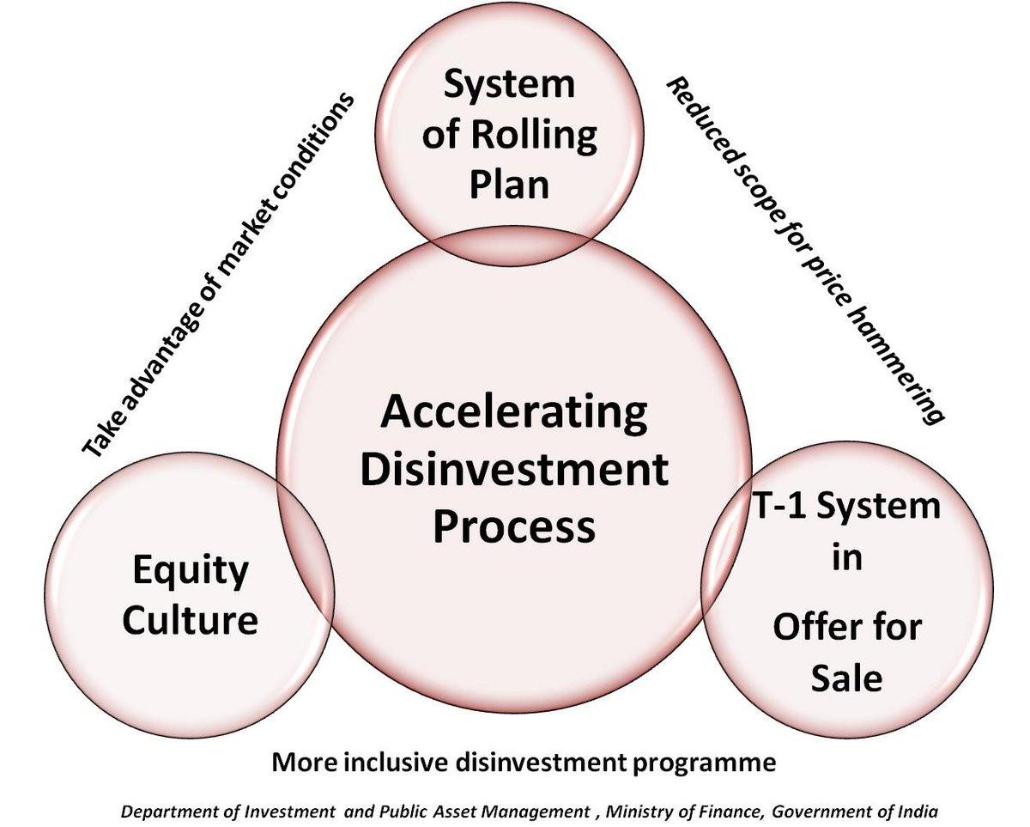

**Importance of disinvestment**

1. Financing the increasing fiscal deficit
2. Financing large-scale infrastructure development
3. For investing in the economy to encourage spending
4. For retiring Government debt- Almost 40-45% of the Centre’s revenue receipts go towards repaying public debt/interest
5. For social programs like health and education
6. Disinvestment also assumes significance due to the prevalence of an increasingly competitive environment, which makes it difficult for many PSUs to operate profitably. This leads to a rapid erosion of value of the public assets making it critical to disinvest early to realize a high value.

**Methods of disinvestment :**

## Public Offer:

* + Offering shares of public sector enterprises at a fixed price through

a genera prospectus.

## Offer for Sale:

* + Offer for sale, determining the fixed price for sale of a public enterprise, inviting open bidders and accepting highest bidder’s quotation for sale

## Sale of Equity:

* + Sale of equity through auction of share amongst pre-determined clientele, whose number can be large. The reserve price for the PSE’s equity can be determined with the assistance of merchant bankers.

## Cross Holding:

* In the case of cross holdings, the government would simply sell part of its shares of one PSU to one or more PSUs.

## Golden Share:

* In this model, the government retains a 26 percent share in the PSU. This 26 percent share will continue to give the Government the status of majority shareholder.

## Warehousing:

* Under this model, the government owned financial institutions were expected to buy the government’s share in select PSUs and holding them until third buyer emerged.

## Strategic Sale:

* + Disinvestment price will be market based and not prefixed

**UNIT-III**

**CRITICAL ANALYSIS OF APPRAISAL TECHNIQUES**

1. **Independent projects** are projects whose cash flows are unrelated to (or independent of) one another; the acceptance of one *does not eliminate* the others from further consideration.
2. **Mutually exclusive projects** are projects that compete with one another, so that the acceptance of one *eliminates* from further consideration all other projects that serve a similar function.

DICSOUNTED PAY BACK

* + Calculates the time it takes to recover the initial investment in current or discounted dollars.
  + Incorporates time value of money by adding up the discounted cash inflows at time 0, using the appropriate hurdle or discount rate, and then measuring the payback period.
  + It is still flawed in that cash flows after the payback are ignored.

EVALUATION

1. It is simple and can be easily understood.
2. It has a great deal of intuitive appeal for risk-averse businessman. It incorporates an attitude (risk-aversion) towards uncertainty.

This approach, however, suffers from the following limitations:

* + There is no easy way of deriving a risk-adjusted discount rate. As discussed earlier, CAPM provides for a basis of calculating the risk- adjusted discount rate. Its use has yet to pick up in practice.
  + It does not make any risk adjustment in the numerator for the cash flows that are forecast over the future years.
  + It is based on the assumption that investors are risk-averse. Though it is generally true, there exists a category of risk seekers who do not demand premium for assuming risks; they are willing to pay a premium to take risks.

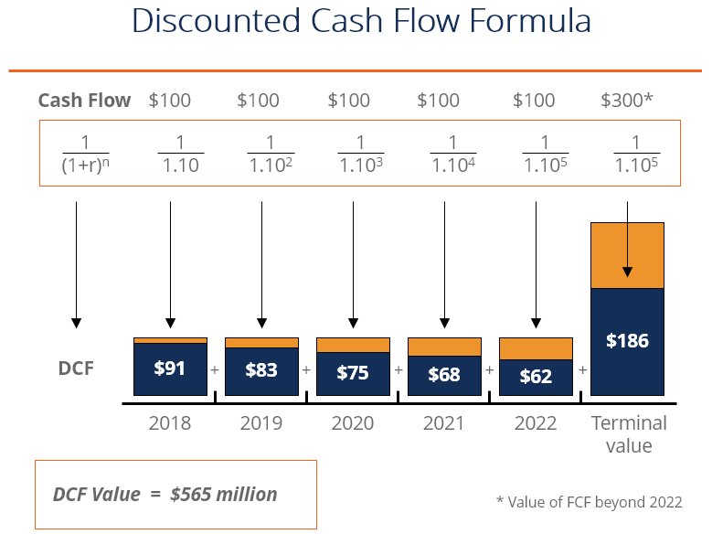

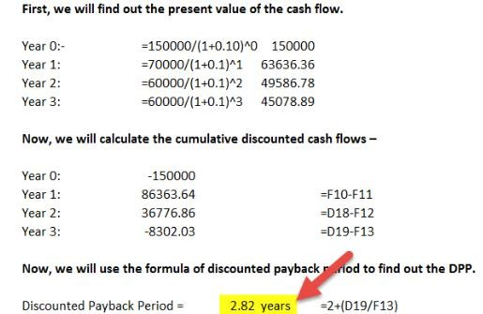

* Nominal Discount rate= (1+Inflation rate)*(1+real rate of discount)-1
* Effect of capital Budgeting Can Be can be incorporated by
* Discounting the money cash flows at nominal discount rate
* Discounting real cash flows at the real discount rate
* management can work out how much extra finance the company will need and take steps to obtain it, e.g. by increasing retention of earnings, or borrowing

## Inflation has the following effects:

Inflation will mean higher costs and higher selling prices. It is difficult to predict the effect of higher selling prices on demand. A company that raises its prices by 30%, because the general rate of inflation is 30%, might suffer a serious fall in demand.

* Inflation, as it affects financing needs, is also going to affect the cost of capital.
* Since fixed assets and stocks will increase in money value, the same quantities of assets must be financed by increasing amounts of capital. If the future rate of inflation can be predicted with some degree of accuracy,
* We need an external interest rate for mixed investments. We will use the MARR as the established external interest rate—the rate earned by money invested outside of the project.
* ⦿ We calculate a rate of return on the portion of capital that remains invested internally—commonly known as the return on invested capital (RIC).
* ⦿ Then select the investment if RIC > MARR.
* FACTORING: The word factor is derived from the Latin word *facere*. It means to make or do or to get things done.
* Factoring simply refers to selling the receivables by a firm to another party.
* The buyer of the receivables is called the factor. Thus factoring refers to the agreement in which the receivables are sold by a firm (client) to the factor (financial intermediary).

Factoring is a method of converting receivables into cash. There are certain objectives of factoring.

1. To relieve from the trouble of collecting receivables so as to concentrate in sales and other major areas of business.
2. To minimize the risk of bad debts arising on account of non- realisation of credit sales.
3. To adopt better credit control policy.
4. To carry on business smoothly and not to rely on external sources to meet working capital requirements.
5. To get information about market, customers’ credit worthiness etc. so as to make necessary changes in the marketing policies or strategies.

**UNIT-IV**

**STRATEGIC INVESTMENT OF SELECTED INVESTMENT DECISIONS**

* + A lease is an agreement whereby the lessor conveys to the lessee , in return for rent, the right to use an asset for an agreed period of time.
    - A financing arrangement that provides a firm with an advantage of using an asset, without owning it, may be termed as ‘leasing’. The Parties
    - The Asset
    - The Term
    - The Lease Rentals

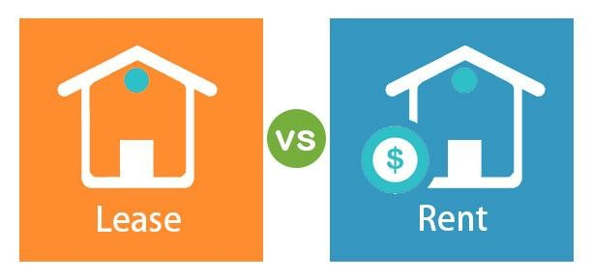

## Avoid Ownership and thereby Avoiding Risks of Ownership:

* + Ownership is avoided to avoid the investment of money into the asset.
  + It indirectly keeps the leverage low and hence opportunities

of borrowing money remain open for the business.

* + A Lease is an off balance sheet item.

Three parties - Manufacturer, lessor(financier) and lessee.

**Guarantee Agreement :** in addition to master lease agreement. Guarantor liable for the due amt. of lessee. He signs the guarantee agreement. If Guarantor is a company then Board Resoultion for the same is a must.

Income and Address proof of Guarantor taken.

Agreement on a stamp paper.

## Promissory Note:

Lessee to execute an unconditional promissory note in favour of lessor for the full amount of lease rentals payable, counter guaranteed by the guarantor.

## Receipt of Goods:

In case of tripartite lease , the manufacturer/ supplier/ lessor, delivers the goods directly to the lessee, so he has the execute the receipt for the goods

## Lessor:

* The depreciation can be claimed by the lessor and not the lessee.
* Depreciation can be charged as a tax deductible expense item

by lessor.

## Lessee:

1. The lease rentals and Insurance, repairs, maintenance charges paid by lessee are tax deductible items of expenses for the lessee
   * which lease –buy model is chosen. Financial theorists and model builders have devoted a substantial amount of time and effort to developing an analytical framework within which the differential costs associated with leasing versus buying can be compared.
   * In spite of this abundance of models, the perplexed financial manager can take some comfort in the fact that the practical effects resulting from the differences in the models tend to be small because few real -world decisions are changed as a result of.
2. Hire purchase is a method of financing of the fixed asset to be purchased on future date. Under this method of financing, the purchase price is paid in installments.
3. Ownership of the asset is transferred after the payment of the last installment.

The main features of hire purchase finance are:

1. The hire purchaser becomes the owner of the asset after

paying the last installment.

1. Every installment is treated as hire charge for using the asset.
2. Hire purchaser can use the asset right after making the

Agreement with the hire vendor.

1. The hire vendor has the right to repossess the asset in case of difficulties in obtaining the payment of installment.

Advantages:

1. Financing of an asset through hire purchase is very easy.
2. Hire purchaser becomes the owner of the asset in future.
3. Hire purchaser gets the benefit of depreciation on asset hired

by him/her.

Disadvantages:

1. Ownership of asset is transferred only after the payment of the last instalment.
2. The magnitude of funds involved in hire purchase are very small and only small types of assets like office equipment’s, automobiles, etc., are purchased through it.
3. The cost of financing through hire purchase is very high.

LEGAL FRAME WORK

* + There is no exclusive legislation dealing with hire purchase transaction in India. The Hire purchase Act was passed in 1972. An Amendment bill was introduced in 1989 to amend some of the provisions of the act. However, the act has been enforced so far.

1. The format / contents of the hire-purchase agreement
2. Warrants and the conditions underlying the hire- purchase

agreement,

1. Ceiling on hire-purchase charges,
2. Rights and obligations of the hirer and the owner

In absence of any specific law, the hire purchase transactions are governed the provisions of the Indian Contract Act and the

1. Sale of Goods Act. In chapter relating to leasing we have discussed the provisions related to Indian Contract Act, here we will discuss the provisions of Sale of Goods Act.

**TAXATION ASPECTS**

There are three aspects of taxation of hire-purchase deals:

1. income-tax,
2. sales tax and,
3. interest tax.

The hire-purchase transaction can be used as a tax planning device in two ways:

1. by inflating the net income (finance income — interest on borrowings by the finance company) at the rear-end of the deal
2. by using hire-purchase as a bridge between the lessor and the lessee, that is, introduction of an sales, are liable to sales tax.

## From the Point of View of the Hirer (Purchaser):

* The tax treatment given to hire purchase is exactly the opposite of that given to lease financing. It may be recalled that in lease financing, the lessor is entitled to claim depreciation and other deductions associated with the ownership of the equipment including interest on the amount borrowed to purchase the asset, while the lessee enjoys full deduction of lease rentals. In sharp contrast, in a hire purchase deal, the hirer is entitled to claim depreciation and the deduction for the finance charge (interest) component of the hire instalment.

1. **Decision criterion:** The decision criterion from the point of view of hirer is the cost of hire purchase vis a vis the cost of leasing. If the cost of hire purchase is less than the cost of leasing, the hirer should prefer the hire purchase alternative and vice-versa.
2. **Cost of hire purchase:** The cost of hire purchase to the hirer consists of the following:

* Down payment and Service Charges
* Present value of hire purchase payments discounted by the
* cost of debt.
* Present value of depreciation tax shield discounted by cot of

capital.

* Present value of net salvage value discounted by cost of capital.

## Balanced cash outflow

* + The biggest advantage of leasing is that cash outflow or payments related to leasing are spread out over several years, hence saving the burden of one-time significant cash payment.
  + This helps a business to maintain a steady cash-flow profile.

## Tax benefit

* Leasing expense or lease payments are considered as operating expenses, and hence, of interest, are tax deductible.

## Off-balance sheet debt

* Although lease expenses get the same treatment as that of interest expense, the lease itself is treated differently from debt.
* Leasing is classified as an off-balance sheet debt and doesn’t appear on company’s balance sheet.

## Better planning

* 1. Lease expenses usually remain constant for over the asset’s life or lease tenor, or grow in line with inflation.
  2. This helps in planning expense or cash outflow when undertaking a budgeting exercise.

## No risk of obsolescence

* For businesses operating in the sector, where there is a high risk of technology becoming obsolete, leasing yields great returns and saves the business from the risk of investing in a technology that might soon become outdated.
* For example, it is ideal for the technology business
* Provisions under Contract Act relating to Bailment:
* two parties - lessor - bailor, lessee-bailee.
* Transfer of possession of goods from bailor(lessor) to

bailee(lessee), for a specific purpose.

* As under bailment, on accomplishment of purpose the goods transferred from lessee to lessor.
* Liabilities of Lessor (Bailor):
* Delivery of Goods:
* - Ensure delivery of goods to the lessee, along with documents for lawful use of asset. Lease commences on delivery.
* Peaceful Possession:
* - Lessor must ensure quite possession of the goods during the

lease term

* Fitness of Goods
* To Disclose All Defects: all known defects to be disclosed. If not then the lessor has to compensate the losses incurred by the lessee due to such defects.

## Remedies for Breach;

1. **Remedies to the Lessor:**

* **Forfeiture :** forfeiture of all lease rentals paid up to the date of termination, even if it exceeds the amt. of benefit received by the lessee.

## Repossession :

* repossession of goods on breach of lease through serving of a notice on lessee.

For repossession of goods physical force can be used by the le

* 1. Insurance of the leased Asset ;
  2. Both lessor or lesse can obtain the insurance.
  3. Generally obtained by the lessee, covering loss due damage by fire, riot, faulty handling, Act of God etc.
  4. Claims Proceeds : in case of asset being fully destroyed, the claims received , adjusted against the lessor’s dues.
  5. Sub Lease by lessee : not allowed unless provided in the lease agreement. Except for assets where sub lease is apparent. Sub lease becomes the lease of the original lessor as well.

ssor

## Clauses in Lease Agreement:

* Nature of the lease : financial lease, operating lease etc.
* Description of the equipment, its actual condition, size, estimated useful life, components etc.
* **Delivery and Re-delivery** : when and how the

equipment would be delivered to the lessee and redelivered by him.

* **Lease Rentals ;** procedure for payments of lease rentals with the rates. Besides, the late payment charges.
* Repairs & Maintenance : responsibility of repairs, insurance etc.
* Title : identification and ownership of equipment.

## Inventory Investment:

Holding of stocks of materials is unavoidable for smooth running of a business. The expenditure on stocks comes in the category of investments.

## Strategic Investment Expenditure:

In this case, the firm makes investment decisions in order to strengthen its market power. The return on such investment will not be immediate.

## Modernization Investment Expenditure:

In this case, the firm decides to adopt a new and better technology in place of the old one for the sake of cost reduction. It is also known as capital deepening process.

## From the Point of View of the Hirer (Purchaser):

The tax treatment given to hire purchase is exactly the opposite of that given to lease financing. It may be recalled that in lease financing, the lessor is entitled to claim depreciation and other deductions associated with the ownership of the equipment including interest on the amount borrowed to purchase the asset, while the lessee enjoys full deduction of lease rentals. In sharp contrast, in a hire purchase deal, the hirer is entitled to claim depreciation and the deduction for the finance charge (interest) component of the hire instalment.

## Expansion Investment on a New Business:

In this case, the firm decides to start a new business or diversify into new lines of production for which a new set of machines are to be purchased.

## Replacement Investment:

In this category, the firm takes decisions about the replacement of worn out and obsolete assets by new ones.

## Expansion Investment:

In this case, the firm decides to expand the productive capacity for existing products and thus grows further in a unit-direction. This type of investment is also called capital widening.

## Need for Investment Decisions:

The need for investment decisions arrives for attaining the long term objective of the firm viz. survival or growth, preserving share of a particular market and retain leadership in a particular aspect of economic activity.

Ec

economic activity.



**Categories of Investment Decisions:**

* .

1. .